Title: Estimating True Emotional State of an Individual by Reading Micro Facial Expressions
Aim: Detection and recognition of micro-facial expressions using non invasive spatio-temporal data in online environment
Objectives:
- Literature review on facial feature detection, extraction and tracking methods for live video feeds
- Classification of micro facial expressions from detected features
- Development of a machine learning model appropriate for identification of emotional state of an individual from one’s micro facial expressions
- Identification of emotional state of an individual being observed based on the developed AI model
- Evaluation of the results with available benchmarks

Research Question

At present (2021), automatic recognition of true emotions is being used in many different areas. Due to the pandemic situation, abundant use of online human interaction has become another opening for reading emotions correctly in the digital sphere. Reading facial emotions of a counterpart has never been this important as in the present context, as no other visual information is available when contacted online. Micro-facial expression (MFEs) will play a great role in measuring the genuineness of emotions. They are spontaneous and subtle facial movements that occur involuntarily within durations 1/25s – 1/3 s. Micro- facial expressions are characterized by short duration and low intensity. Hence, efforts to train humans in recognizing them have resulted in very low performances. Automatic recognition of micro- facial expressions using machine learning techniques thus promises a more effective result and saves time and resources. The purpose of this research is to recognize the display of micro- facial expressions displayed in online environments to identify whether the expressed emotion is real or fake.

Why

Micro-facial expressions (MFEs) help detect genuine emotions but are difficult for humans to recognize. Machine learning offers a more effective solution for automatic MFE recognition. This research aims to identify real vs. fake emotions in online environments.

Literature Review

Facial Expression vs Micro-facial Expression

Emotions are the feelings that naturally caused by the situation and that can cause individual to act in certain ways. Feelings are often revealed through non-verbal body language, and among them, facial expressions play the most crucial role. Facial expression is a movement of facial muscles [1] that create folds, lines, and wrinkles in the skin and cause movement of facial landmarks such as mouth corners and eyebrows forming a basic non verbal communication such as smiling or frowning to indicate happiness or anger respectively.

In some situations, people may not want to reveal their true emotions. However, facial expressions (FE) are often spontaneous [2], and through them, emotions can "leak out" [1]. When individuals realize that a facial expression is occurring, they may try to suppress it [3]. As a result, these expressions are characterized by 3S- spontaneous, subtle and short duration and hence, with incomplete facial muscle movements. Consequently, they appear with low intensity. These types of facial expressions are known as Micro Facial Expressions [4].

Distinct Facial Expressions

The typical human face has 43 different muscles that can be activated around the eyes, nose, mouth, jaw, chin and brow to make thousands of different expressions [6]. Starting with six basic emotions (happiness, sadness, fear, anger, surprise, and disgust) [14] research has expanded to recognize at least 21 distinct facial expressions [7] correspond to various emotional states, by identifying combinations and subtler emotional nuances.
Universal or Cultural Specific

The concept of universality of facial expressions of emotions originated by Darwin, in 1872 suggesting that facial expressions of emotions are biologically hardwired and universally recognized across cultures [2]. Cross-cultural studies, discovered that several facial expressions of emotion were universal [3], and that people could easily read these expressions in people from different cultures but cultural differences influence the way emotions are expressed and interpreted.

There are seven emotions identified as universal: happiness, surprise, sadness, anger, disgust, fear, contempt, and neutral [1]. Additionally, 16 types of facial expressions have recently been recognized, as they systematically occurred in thousands of contexts across six million videos from 144 countries. Each type of facial expression had distinct associations with a set of contexts, which were 70% preserved across 12 world regions [6].



Despite cultural differences in emotional expression and suppression, the spontaneous and rapid nature of micro-expressions reflects genuine emotions that are universally recognizable. In the context of Micro-Expression Recognition (MER), this foundation is crucial because micro-expressions often reveal concealed emotions, bypassing cultural masking or social norms. . This suggests that, despite cultural variations in emotional expression, micro-expressions serve as a universal language of emotion
Emotional or Volitional Nature of Facial Expression
Facial expressions typically last for a few seconds and can be consciously controlled through voluntary muscle movements. In contrast, micro-expressions (MEs) are brief, involuntary facial expressions that appear for a fraction of a second [9].
While facial expressions are usually spontaneous and emotionally driven, they can also be intentionally produced, such as smiling for a photo [1]. Repressed emotions and the display of fake emotional states may occur either intentionally or unintentionally. Moreover, emotions not only cause facial expressions but can also be influenced by them [5]. This interplay makes it particularly challenging to recognize a person’s true underlying emotions.
Voluntary and involuntary facial expressions are controlled by separate neural pathways: Pyramidal and Extra-pyramidal systems in brain [1]. A classic dissociation: Motor cortex damage prevents voluntary smiles but naturally smile when genuinely happy, while Parkinson’s disease reduces spontaneous expressions but allows smiling intentionally [1]. This reinforces that emotional expressions are neurologically distinct from volitional facial movements.
This aligns with the theory of universal facial expressions by explaining how involuntary, emotional expressions are controlled by the extra-pyramidal system, making them biologically hardwired and universal [1]. Meanwhile, voluntary facial expressions are controlled by the pyramidal system, which allows cultural and social influences on facial behavior [1].
Face Action Coding System
Each facial muscle contracts that changed the facial appearance were defined as action unit (AU). AUs correspondent to each emotional state are defined in Face Action Coding System (FACS) [14] and that has been the foundation for the ME recognition systems (MER). MER involves recognizing these micro-scale facial muscle movements that describes hidden emotions.

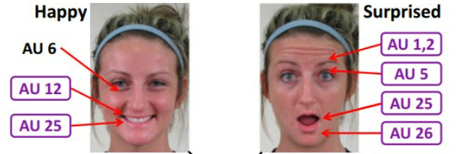
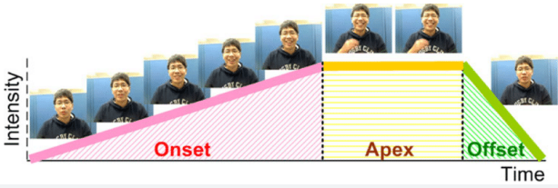

A regular Facial Expression (FE), typically last for between 0.5 to 4 or more seconds, and move through distinct phases of onset (start of the expression), apex (peak expression) and offset (return to neutral) [16]. The FACS uses this sequence and distinct AUs in each phase to classify them into emotion classes. An ME on the other hand, last only between 0.2 to 0.5 seconds [15] with partial therefore very subtle and low intensity and potentially incomplete facial muscle movement and spatially localized (eyes, eyebrows, lip corners). These make them difficult to be detected and coded as AUs in FACS [17].

Because of these properties, MER systems must capture very small facial muscle movements, preserve subtle spatial variations, model short temporal evolution (onset, apex & offset) and avoid over-fitting on small datasets

Datasets

There are three types of databases posed, spontaneous and in-the-wild; laboratory-controlled posed FE data does not represent involuntary MEs [12] while in-the-wild dataset represent true MEs in real situation yet with difficulty in feature extraction [11] for many reasons. As that spontaneous Micro expression databases where participants were asked to suppress the emotion and neutralize MEs [12] are considered as better resources for our research study. From those available spontaneous ME datasets high speed recorded videos (above 100fps) labeled with AUs for expressions of the basic emotions are considered and CSAME II & SIMM are considered suitable since both are annotated with AUs and Onset, Apex & Offset frames [12].

Not all videos contain MEs, and when they occur in brief durations, so micro-expression spotting is required. Furthermore detecting ME features require higher resolution and high-frame rate inputs compared to FE feature detection, due to the subtler and less intense muscle movements involved.

Traditional vs Modern Technology

Conventional techniques in MER rely on handcrafted feature extraction followed by classical classifiers. These approaches have largely been replaced by deep learning neural networks [10] due to their ability to automatically learn discriminative features, perform end-to-end classification and leverage transfer learning to improve performance across related tasks. Deep learning neural networks have multiple layers that allow for the progressive extraction of higher-level features from raw input and capture intricate patterns and relationships [10].
Deep learning models such as CNNs and RNNs were first widely adopted for MER. However, due to the subtle and short-lived nature of micro-expressions, modeling long-range spatial and temporal dependencies is essential. This led to the adoption of Transformer-based architectures which use self-attention to capture global relationships to image-based feature extraction.
Transformers for Image Recognition enabled global spatial modeling by treating image patches as tokens. However, computing global self-attention is computationally expensive for high-resolution facial images.
To address this, the Swin Transformer: Hierarchical Vision Transformer using Shifted Windows introduced a hierarchical shifted window mechanism. Instead of applying attention over the entire image, attention is computed within local windows, significantly reducing computational cost. By shifting the windows between layers, cross-window interactions are enabled, allowing the model to capture both fine-grained local details and broader contextual information without full global attention.
This hierarchical design is particularly valuable in MER, where subtle facial movements may span across different regions of the face. The shifted window structure allows efficient modeling of these spatial dependencies while maintaining high performance, making it well suited for video-based micro-expression recognition.
For video-based MER, models such as ViViT, introduced divided spatial–temporal attention mechanisms, which are currently among the state-of-the-art approaches for capturing subtle spatiotemporal dynamics.
For better accuracy in MER, especially when working with video data, transformers are usually more effective than other NNs. They can capture long range spatial relationships and temporal relationships, which are the key for MER. However, transformers are more computationally demanding and require more data to work at their best, so they might be slower and harder to train.
Despite their strong performance, transformers have quadratic computational complexity and require large datasets, which is challenging for MER due to limited labeled data (e.g., CASME II).
To address efficiency limitations of attention-based models, recent research has introduced structured State Space Models (SSMs), particularly Mamba, which replaces self-attention with selective state-space modeling. Instead of computing pairwise interactions between all tokens, Mamba captures long-range dependencies through structured state transitions, reducing computational complexity from quadratic to linear scale. This makes it highly efficient for sequential data such as video frames while preserving strong temporal modeling capability.
Therefore, the current state-of-the-art in MER is largely dominated by transformer-based spatiotemporal architectures, often enhanced with hierarchical spatial modeling strategies such as the Swin Transformer: Hierarchical Vision Transformer using Shifted Windows and efficient temporal modeling mechanisms. The emerging trend is toward hybrid and structured models that balance accuracy with computational efficiency, motivating the proposed Swin–Mamba based design.
Micro-facial expressions (MEs) are subtle and difficult to detect even for humans. To effectively capture these fine-grained spatiotemporal variations, researchers have explored various deep learning configurations, including single-stream networks, multi-stream networks, cascaded networks, multi-task learning frameworks, and transfer learning strategies. These architectures aim to enhance feature representation, improve robustness under limited data conditions, and better model the subtle dynamics of micro-expressions.

Contributions
- We propose a structured spatio-temporal architecture for MER that integrates hierarchical Swin-style spatial encoding with state-space temporal modeling.
- We introduce orthogonal spatial Mamba blocks that perform orthogonal traversals to enhance sensitivity to anisotropic facial muscle activations.
- We design a bidirectional temporal state-space module with learnable fusion to effectively model onset–apex–offset dynamics.
- The proposed framework achieves linear temporal complexity while preserving bidirectional sequence understanding.
- The architecture injects direction-aware inductive bias tailored specifically for subtle micro-expression dynamics.
- Together, these components form a domain-aligned, computationally efficient alternative to conventional CNN–RNN and transformer-based MER models.
Proposed Design Architecture
The micro-expression recognition (MER) pipeline begins with preprocessing and sampling of the input videos. Each video is first converted to grayscale, aligned, cropped to focus on relevant facial regions, resized to a standard resolution, and resampled to a consistent frame rate. The output of this stage is a tensor of shape (B, T, C, H, W), where B is the batch size, T is the number of frames, C represents the channels, and H and W are the height and width of the frames. This normalization ensures that all video clips are consistent for subsequent feature extraction.
Next, the preprocessed frames are fed into the Swin Orthogonal Spatial Mamba, which operates independently on each frame. For every frame of shape (B, C, H, W), the spatial backbone extracts fine-grained features, resulting in a 512-dimensional feature vector per frame. After processing all T frames, these features are stacked to form a tensor of shape (B, T, 512). This stage captures subtle spatial details in individual frames, which are critical for detecting micro-expressions that are often very short and localized.
The frame feature stacking serves as the bridge between the spatial and temporal modules. By collecting all per-frame embeddings into a temporal sequence representation, the model converts spatial features into a format suitable for temporal modeling. The Bidirectional Temporal Mamba then processes this sequence, analyzing temporal dynamics both forward and backward. This allows the model to capture the subtle evolution of micro-expressions over time, ensuring that even brief or weak facial-cues are recognized.
Finally, temporal pooling aggregates the learned features over time, reducing the temporal dimension while retaining discriminative information. The resulting representation is then fed to a classifier, which predicts the micro-expression class. This modular design, separating spatial and temporal processing, is crucial for accurately capturing the fine and fleeting patterns characteristic of micro-expressions. The frame feature stacking is therefore an essential component, enabling the temporal module to operate on meaningful, high-level embeddings rather than raw frames.
Novelty
In MER, the integration of structured state-space models (SSMs) for both spatial and temporal modeling remains largely underexplored. This work introduces a task-specific architectural integration that combines hierarchical Swin-based spatial feature extraction with direction-aware Orthogonal Spatial Mamba and Bidirectional Temporal Mamba modules.

Rather than proposing an entirely new backbone, the novelty lies in how structured state-space modeling is systematically incorporated to enhance directional sensitivity and long-range dependency modeling for subtle micro-expression dynamics. To the best of our knowledge, such unified spatial–temporal SSM integration tailored for MER has not been explicitly investigated.
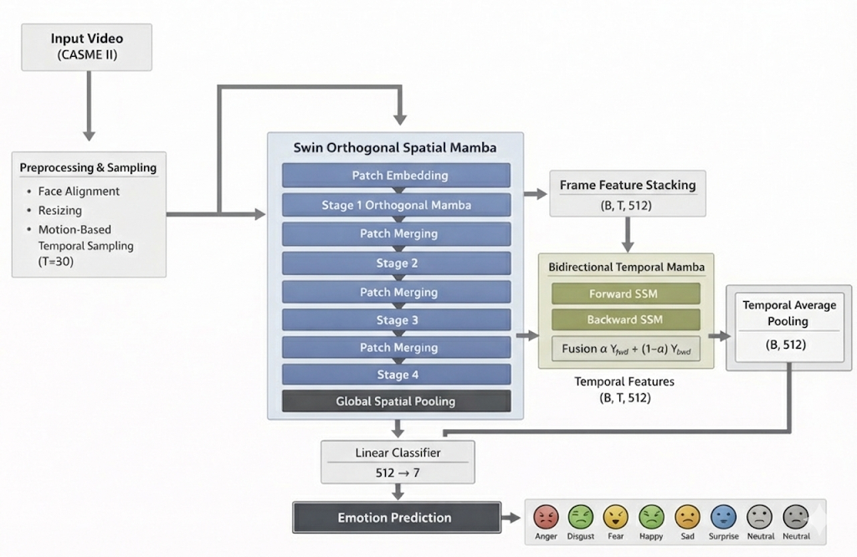

Methodology

This work is currently implemented using the CASME II dataset.
Since CASME II is small, careful preprocessing is essential:
- Face detection and alignment
- Facial region cropping
- Frame standardization
- Temporal normalization (fixed-length sequences)
- Spatial resizing for backbone compatibility
This ensures consistent inputs while preserving subtle motion cues.

Dataset Preparation

The CASME II dataset, along with SMIC and SAMM, contains video data with labeled frames for the onset, apex, and offset, as well as five facial expression categories. After getting authorized access, the data will be gray scaled, as it won’t affect accuracy []. Face alignment and cropping will be done to focus on relevant parts of the face, making the process more efficient. Since transformers need standardized input, the frame rate will be up-sampled to 30 fps to capture more details of the short micro-expressions (ME). The resolution will also be adjusted to make sure the frames match the input format of the prototype. To fit the requirements of the Swin Transformer model, the frames will be resized to square shapes before being split into patches. These steps will be applied to the CASME II dataset first, with plans to do the same for SMIC and SAMM.
Frame Detection
- Frame-wise annotations exists; hence, the model can learn automatically. But separate frame detection is preferred to reduce the burdenon MER network
- Prototype development start with
  - Identified frames
  - Separate apex/onset frame detection network
  - Use of Adaptive sampling (built-in with the transformer)to dynamically select the key frames and spatial areas (as it needs to spot Onset Apex frames for real-time prediction)

Splitting Frames into Patches
- Image size 224x224 pixels
- Patch size: 14x14 pixels
- Number of Patches = 224/14 x 224/14 (276)
- patch merging 28 56 112 224 -5 stage SWin
- Skip non-ROI patches

Input Embedding
- Conv3D patch projection and Flatten projects each patch into a linear vector
- Embedding dimension – (16x16 patch -> 768 Input Embedding)
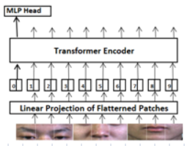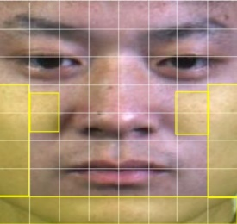

Training & Testing

The training process involves splitting the data into a 60:20:20 ratio for training, validation, and testing. The model is set up either with pre-trained weights or trained from scratch. In an ablation study, you would systematically test different loss functions (e.g., Cross Entropy, Center Loss, and Focal Loss) individually or in combination to evaluate their impact on model performance. Training is conducted using GPUs. Model performance is evaluated based on accuracy, F1-score, and cross-validation (Leave-One-Subject-Out), along with testing on unseen data for real-world evaluation. Key training parameters, including batch size, the number of layers, and epochs, are optimized through hyper-parameter tuning to achieve the best results.

Evaluation
- Accuracy – measures the ration of correct predictions
  - Susceptible to bias data
- F1 Score – gives true classification performance
  - For composite datasets ( Server Imbalance)
  - Unweighted F1 Score
    - Provides equal emphasis on rare classes
=Average Accuracy of the Class/ No. of Classes
  - Unweighted Average Recall
=No of correctly classified samples/ total no. of samples
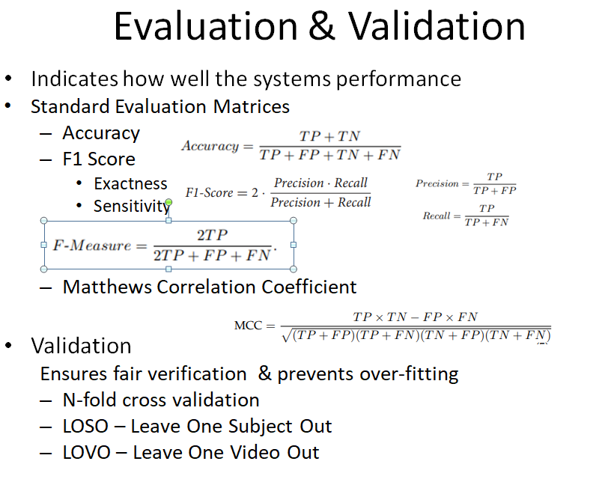

References
- Rinn WE. The neuropsychology of facial expression: a review of the neurological and psychological mechanisms for producing facial expressions. Psychol Bull. 1984 Jan;95(1):52-77. PMID: 6242437.
- Darwin, C. (1872). The expression of the emotions in man and animals. John Murray. https://doi.org/10.1037/10001-000
- Ekman, P. (1972). Universal and Cultural Differences in Facial Expression of Emotions. In J. Cole (Ed.), Nebraska Symposium on Motivation (pp. 207-283). Lincoln: University of Nebraska Press.
- Porter, S., & ten Brinke, L. (2008). Reading between the lies: Identifying concealed and falsified emotions in universal facial expressions. Psychological Science, 19(5), 508–514. https://doi.org/10.1111/j.1467-9280.2008.02116.x
- Davis JI, Senghas A, Ochsner KN. How Does Facial Feedback Modulate Emotional Experience? J Res Pers. 2009 Oct 1;43(5):822-829. doi: 10.1016/j.jrp.2009.06.005. PMID: 20160935; PMCID: PMC2764988.
- Cowen, A.S., Keltner, D., Schroff, F., Jou, B., Adam, H., & Prasad, G. (2020). Sixteen facial expressions occur in similar contexts worldwide. Nature, 589, 251 - 257.
- Compound facial expressions of emotion Shichuan Du, Yong Tao, and Aleix M. Martinez1 2014
- Brooks JA, Kim L, Opara M, Keltner D, Fang X, Monroy M, Corona R, Tzirakis P, Baird A, Metrick J, Taddesse N, Zegeye K, Cowen AS. Deep learning reveals what facial expressions mean to people in different cultures. iScience. 2024 Feb 10;27(3):109175. doi: 10.1016/j.isci.2024.109175. PMID: 38433918; PMCID: PMC10906517.
- Yan, W.-J., Wu, Q., Liang, J., Chen, Y.-H., & Fu, X. (2013). How fast are the leaked facial expressions: The duration of micro-expressions. Journal of Nonverbal Behavior, 37(4), 217–230
- Li, Y., Wei, J., Liu, Y., Kauttonen, J., & Zhao, G. (2022). Deep learning for micro-expression recognition: A survey. IEEE Transactions on Affective Computing, 13(4), 2028–2046. https://doi.org/10.1109/TAFFC.2022.3205170
- Weber, R., Li, J., Soladié, C., & Séguier, R. (2018, January). A survey on databases of facial macro-expression and micro-expression. In International Joint Conference on Computer Vision, Imaging and Computer Graphics (pp. 298-325). Springer, Cham.
- Hang PAN, Lun XIE, Zhiliang WANG, Bin LIU, Minghao YANG, Jianhua TAO. Review of micro-expression spotting and recognition in video sequences. Virtual Reality & Intelligent Hardware, 2021, 3(1): 1—17 DOI: 10.1016/j.vrih.2020.10.003
- Dosovitskiy, A., Beyer, L., Kolesnikov, A., Weissenborn, D., Zhai, X., Unterthiner, T., Dehghani, M., Minderer, M., Heigold, G., Gelly, S., Uszkoreit, J., & Houlsby, N. (2020). An image is worth 16x16 words: Transformers for image recognition at scale. In International Conference on Learning Representations.
- Friesen, W. V., & Ekman, P. (1978). Facial action coding system: A technique for the measurement of facial movement. Palo Alto, 3, 1-60.
- Yan, W.-J., Wu, Q., Liang, J., Chen, Y.-H., & Fu, X. (2013). How fast are the leaked facial expressions: The duration of micro-expressions. Journal of Nonverbal Behavior, 37(4), 217–230
- Li, Y., Wei, J., Liu, Y., Kauttonen, J., & Zhao, G. (2022). Deep learning for micro-expression recognition: A survey. IEEE Transactions on Affective Computing, 13(4), 2028–2046. https://doi.org/10.1109/TAFFC.2022.3205170 7. Han, K., et al. (2023). A survey on vision
- Vaswani, A., Shazeer, N., Parmar, N., Uszkoreit, J., Jones, L., Gomez, A. N., Kaiser, L., & Polosukhin, I. (2017). Attention is all you need. In Advances in Neural Processing Systems (Vol. 30).
- Arnab, A., Dehghani, M., Heigold, G., Sun, C., Lučić, M., & Schmid, C. (2021). ViViT: A video vision transformer. In Proceedings of the IEEE/CVF International Conference on Computer Vision (pp. 6836–6846).
- Bertasius, G., Wang, H., & Torresani, L. (2021, July). Is space-time attention all you need for video understanding?. In ICML (Vol. 2, No. 3, p. 4).

